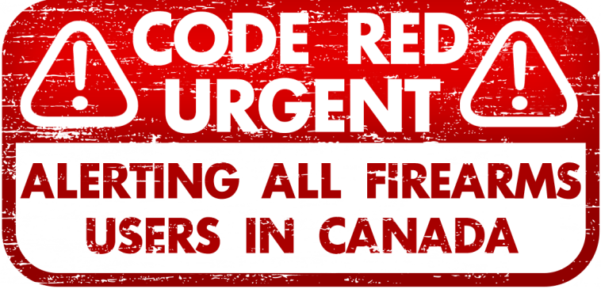
<<Name>>
<<AddLine1>>
<<AddLine2>>
<<PostalCode>>

Spring 2023

Dear <<Name>>,

This is a Code Red Urgent for all law-abiding firearms users across Canada.
As I write you, Prime Minister Justin Trudeau is on a crusade to strip law-abiding Canadian gun owners like you and me of our cherished rights and freedoms, and we need to act NOW before his civil disarmament agenda is fully implemented.
That's why I'm asking you to sign both of the Hands Off Our Guns Petitions enclosed with this letter and return them to me without delay using the postage-paid envelope provided.
Your first Hands Off Our Guns Petition is addressed to Canada’s top gun grabber himself, Justin Trudeau. It demands that he:
- End his civil disarmament program,

- Reverse his authoritarian handgun ban,
- Restore the rights of law-abiding firearms users across Canada IMMEDIATELY.
Your second Hands Off Our Guns Petition urges Conservative leader Pierre Poilievre to stand strong against Trudeau's tyranny and fight tooth and nail for our rights in Parliament, in the media, and on the campaign trail.
Both petitions are vital to the fight for our rights, so please sign both and return them to me today using the postage-paid envelope provided.
The organization I lead, Canada’s National Firearms Association (NFA), launched this new petition drive as part of our mission to fight for your freedoms.
You may already be familiar with the NFA as the largest and most powerful organization in Canada devoted to protecting the rights of law-abiding firearms users.
Established in 1978, the NFA has been at the forefront of defending our sport, our heritage, and our freedom from anti-gun fanatics like Trudeau.
But, with Justin Trudeau’s Liberals totally hell-bent on taking our guns away, the NFA needs your help NOW more than ever!
Justin Trudeau's recent handgun ban is a blatant assault on our rights, punishing responsible gun owners instead of targeting criminals. But it only gets worse from here.
In my opinion, the handgun ban is just the beginning of Justin Trudeau’s tyrannical plan to permanently disarm all Canadians!
The good news is that the NFA has a proven track record of defeating gun control schemes like this.
Just last year, the NFA thwarted a proposed ban on popular hunting rifles and shotguns, saving thousands of Canadians from having their legally owned firearms confiscated by the government.
But the NFA can't continue fighting these battles without your help, which is why I need your two Hands Off Our Guns Petitions ASAP.
By signing and returning both petitions, you're not only demanding an end to Trudeau's destructive disarmament agenda, but you're also showing Pierre Poilievre that firearms users across the nation are counting on him to stand up for our rights.
The more signatures we collect, the more powerful our message will be – and the more difficult it will be for Trudeau and his anti-gun allies to trample our rights under their iron heel.
But the NFA's fight for our rights comes at a cost.
That's why, in addition to rushing me your two signed petitions, I’m asking you to consider making a contribution of $25, $50, $100, $250, $500, or even $1,000 or more to support the NFA.
Your gift will help the NFA carry on its vital work, including lobbying lawmakers, providing legal assistance to gun owners in need, and revealing the horrifying truth behind Trudeau's Communist-style civil disarmament campaign.
And your gift will help us overcome the lies Liberal, NDP, and Bloc Québécois MPs routinely tell Canadians about the NFA.
It was only a few months ago when some of these left-wing gun grabbers implied to a parliamentary committee that the NFA supports civil disobedience and that we want to erase ALL gun laws.
And who do you think the anti-gun, liberal news media outlets like the CBC listen to? It may sound crazy, but that’s what we’re up against!
Yes, the situation facing Canadian firearms users today is dire.
But I wouldn’t be writing you if I didn’t believe that you and I can together show Trudeau and his cronies that we won't be silenced, and we won't let our rights be crushed by his tyrannical policies.
So please, sign the enclosed Hands Off Our Guns Petitions and return them to me today.
And if you're able, please consider supporting the NFA with a gift of $25 or more today.
Your support will make a world of difference in the fight to protect our cherished rights and freedoms.
Don't let Trudeau's vile civil disarmament agenda go unchallenged. Stand with the NFA, and help us send a thunderous message that we will NEVER let our rights be taken away.
Thank you in advance for your support, and for your unwavering commitment to defending our shared heritage and values.
United, we can make a difference and safeguard the rights of law-abiding firearms users across Canada.

Sincerely,
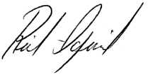
Rick Igercich
National President & CEO,
National Firearms Association

P.S. The battle against Justin Trudeau's sinister civil disarmament agenda is more crucial and urgent than ever, and the NFA desperately needs your help to stand up for the rights of law-abiding gun owners.
Please sign and return both Hands Off Our Guns Petitions today, and support the NFA with a gift of $25, $50, $100, $250, $500, or $1,000 or more.
Remember, every signature and every dollar counts – so please, don't wait. Act now to protect our rights and preserve our heritage. Thank you.

